MISSIONARIES AND CANNIBALS PROBLEM
Aim
To develop a program that safely transfers three missionaries and three cannibals across a river without ever allowing the cannibals to outnumber the missionaries on either riverbank.

Objectives
- To understand the Missionaries and Cannibals state-space problem.
- To find a valid sequence of moves from the initial state to the goal state.
- To ensure missionaries are never outnumbered by cannibals on either bank.
- To implement the solution using the Breadth-First Search (BFS) algorithm.
- To obtain the shortest valid path from the start state to the goal state.

Algorithm (Breadth-First Search - BFS)
- Represent each state as (Missionaries Left, Cannibals Left, Boat Position).
- Start from the initial state (3, 3, Left).
- Generate all valid successor states by moving one or two people.
- Discard invalid or previously visited states.
- Add valid states to the queue.
- Continue exploring until the goal state (0, 0, Right) is reached.
- Display the sequence of states representing the solution path.

Flowchart
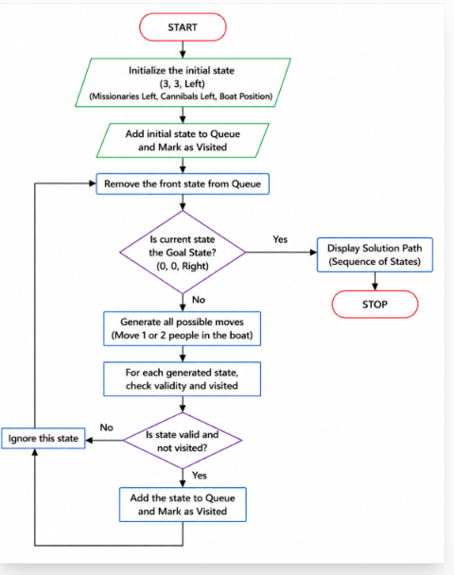

Code
from collections import deque

def valid(m, c):
if m < 0 or c < 0 or m > 3 or c > 3:
return False
if (m > 0 and m < c):
return False
if (3-m > 0 and 3-m < 3-c):
return False
return True

moves = [(1,0),(2,0),(0,1),(0,2),(1,1)]

queue = deque([((3,3,1), [])])
visited = {(3,3,1)}

while queue:
(m,c,b), path = queue.popleft()

if (m,c,b) == (0,0,0):
print("Solution Path:")
for state in path + [(m,c,b)]:
print(state)
break

for dm, dc in moves:
if b == 1:
nm, nc, nb = m-dm, c-dc, 0
else:
nm, nc, nb = m+dm, c+dc, 1

if valid(nm, nc) and (nm,nc,nb) not in visited:
visited.add((nm,nc,nb))
queue.append(((nm,nc,nb), path + [(m,c,b)]))

Output
